Project Design Phase
Solution Architecture
Date | 19 July 2026
Team ID | [Fill in your Team ID]
Project Name | Book A Doctor – Online Doctor Appointment Booking System
Maximum Marks | 4 Marks

Solution architecture is a complex process — with many sub-processes — that bridges the gap between business problems and technology solutions. Its goals are to find the best tech solution to solve existing business problems, describe the structure, characteristics, and behavior of the software to project stakeholders, define features and development phases, and provide specifications according to which the solution is defined, managed, and delivered.
Book A Doctor — Solution Architecture Diagram
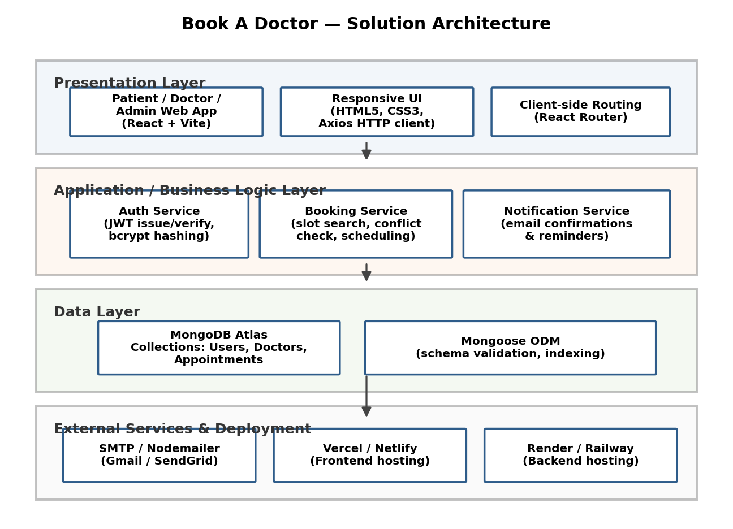
Figure 1: Layered architecture and data flow of the Book A Doctor application
Layer-by-Layer Description
Presentation Layer: A React (Vite) single-page application shared by all three roles — Patient, Doctor, and Admin — with role-based views. It communicates with the backend exclusively over HTTPS REST calls made via Axios, and uses React Router for client-side navigation between the search, booking, and dashboard screens.
Application / Business Logic Layer: An Express.js server exposes REST endpoints grouped into three services. The Auth Service issues and verifies JWTs and hashes passwords with bcrypt. The Booking Service handles doctor search, slot availability, and conflict-checking so two patients can never claim the same slot. The Notification Service triggers confirmation and reminder emails whenever a booking is created, updated, or cancelled.
Data Layer: MongoDB Atlas stores three core collections — Users, Doctors, and Appointments — accessed through Mongoose, which enforces schema validation and maintains indexes on frequently queried fields (specialization, location, appointment date) to keep search fast as data grows.
External Services & Deployment: Nodemailer connects to an SMTP provider (Gmail or SendGrid) to deliver transactional emails. The frontend is deployed on Vercel or Netlify, and the backend on Render or Railway, with MongoDB Atlas providing managed, geographically-distributed database hosting.
Design Principles Followed
- Separation of concerns: presentation, business logic, and data are independently deployable layers.
- Statelessness: JWT-based auth means any backend instance can serve any request, simplifying horizontal scaling.
- Single source of truth: appointment availability lives only in MongoDB, eliminating the double-booking problem identified in the Problem Statement phase.
- Fail-safe notifications: booking confirmation happens synchronously; the reminder email is decoupled so a temporary email-service outage never blocks a booking.
Note on Diagrams
The diagram above was generated to represent the actual architecture of the project you are running (React + Express + MongoDB Atlas). If your team has its own architecture diagram — drawn in draw.io, Lucidchart, Figma, or similar — send it and it will be inserted here in place of the generated one.

